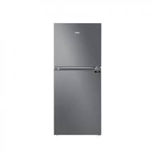

Haier 368EB

* Faster Cooling & Freezing
* 1HIT Technology
* Color Grey
* Voltages 125v~260v
* **Rs.53,500**